Purpose of document: Triaging individuals with Perinatal Depression for IMH-HV professionals

**Perinatal Depression has been identified, now what?**

Identifying the next step for addressing perinatal depression is a frequent question for providers as they assess perinatal depression. Thankfully, there are a number of options that may support people with perinatal depression. The options are often related to the patients presenting problems and concerns, as well as the severity of those concerns.

Professionals are encouraged to use multiple sources of information to make a decision regarding the treatment that may support the patient and different levels of experience, and available resources will influence this decision making.

It is also important to consider what the patient may want to address. If the patient is noticing they are feeling sad and low, and this is related to not being able to shower every day, it may be that the best intervention is helping the patient to figure out a way to get in the shower- that could be identifying support to take care of the baby. It could also be that the patient does not have adequate food or resources, or their neighborhood is not safe to walk in. Considering the social drivers of health will also support the patient on a pathway to wellness for themselves and their infant. Using IMH principles of being curious and observing, can provide ports of entry into supporting patients in addressing the source of their symptoms.

Michigan Clinical Consultation and Care (MC3) has created a helpful guides to determine [severity](https://mc3michigan.org/assessment-of-depression-severity/) and [treatment](https://live-med-mc3.pantheonsite.io/wp-content/uploads/2025/07/treatment-options-by-symptom-severity-PDF.pdf) based on severity.

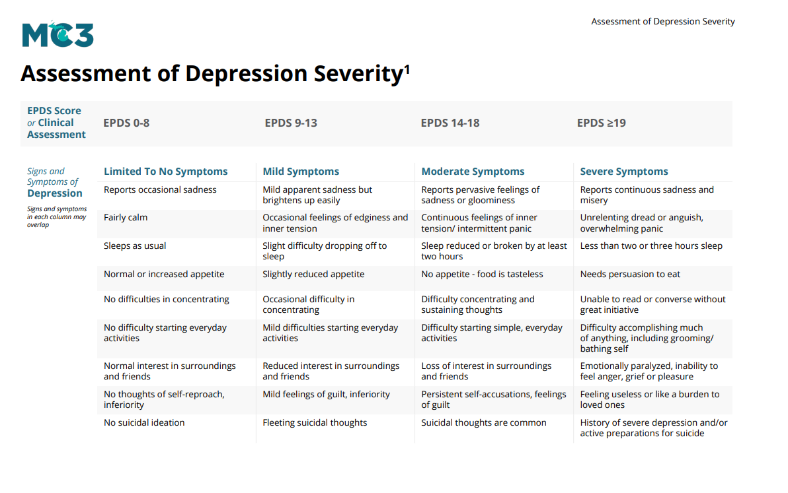

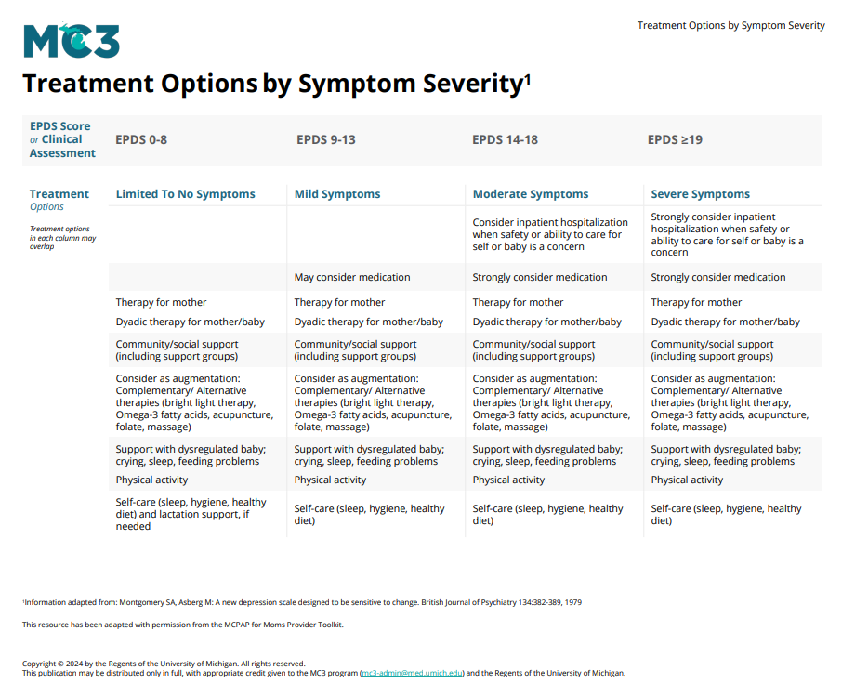

**What about risk?**

Thoughts of not wanting to be alive, or of hurting the self, or sometimes hurting others are not unheard of during the perinatal period. According to recent research 5-22% of individuals experience suicidal ideation during the perinatal period (Chin, Wendt, Bennett, and Bhat, [2022](https://link.springer.com/article/10.1007/s11920-022-01334-3)). Some may also find it surprising while others may find it validating, that 100% of mothers report unwanted, intrusive thoughts that their infant may be harmed or they may accidentally harm their infant (Fairbrother & Woody, [2008](https://link.springer.com/article/10.1007/s00737-008-0016-7)). It is recommended that IMH-HV professionals and organizations identify and determine a workflow for risk identification and assessment that meets their organization’s standards and policies. Below are some recommended resources and workflows that may support this practice.

Clinicians may review the self-report depression screen including the question regarding suicidal ideation. If this question is endorsed the clinician may follow up with the patient about the thoughts by completing a thorough risk assessment. The Columbia-Suicide Severity Rating Scale ([CSSRS](https://www.cms.gov/files/document/cssrs-screen-version-instrument.pdf)) is a commonly used tool that helps to identify individuals severity of suicidal ideation. This combined with the [SAFE-T](https://library.samhsa.gov/sites/default/files/safet-flyer-pep24-01-036.pdf) can help determine the best intervention for patients. If you would like additional training on suicide and crisis assessment and screening, speak with other trusted professionals about resources, and identify workshops or educational supports that will meet these needs for you.

The University of British Columbia has the Perinatal Anxiety Research Lab (PARLab) that researches perinatal anxiety disorders and has educational materials on anxiety in pregnancy. One resource is an [infographic](https://parlab.med.ubc.ca/infographic-on-postpartum-harm-thoughts/infographic-april-2023/) on postpartum harm thoughts which is helpful to be aware of and use with patients as patients to understand their experience of intrusive thoughts.

If a patient is presenting with psychosis this is considered an emergency. Delusions are beliefs that people may assert even though there may be clear evidence to the contrary. Delusions may be the belief that a patient is being watched or followed with there is not evidence that this is happening, or the belief that the patient has an exaggerated importance. Hallucinations occur when people have sensory experiences (hearing, seeing, smelling, tasting, feeling something) that the patient may be feeling although there is not something that is triggering or promoting that sensory experience. This may occur when patients see something that others do not see, or hear something that others may not hear. Psychosis is important to address as it creates a significant safety burden for the patient and the child as a patient is not equipped to appropriately care for an infant or themselves due to inability to accurately assess danger in the environment and the ability to keep themselves and others safe.

**When should a patient be referred to higher levels of care?**

If after completing a crisis assessment a patient is presenting with severe concerns it is important to connect the patient to appropriate levels of care. Psychiatric hospitalization may be appropriate for a patient if they are not caring for themselves or others and this is impacting their and their families wellbeing or health. If a patient is not ensuring their own or others safety, nor providing appropriate care or supervision of children, they may benefit from a higher level of care. As noted above, if a patient is falling within a high risk for suicide or experiencing psychosis, the patient should receive a crisis psychiatric evaluation at a hospital or other appropriate facility.

**Resources:**

https://mc3michigan.org/higher-levels-of-care/