The Wheel of Power and Privilege by Sylvia Duckworth

This is a tool used to think about different power dynamics across different interactions. During Booster Session 2 we will use the Wheel of Power and Privilege to reflect on our own position. Consider the following prompts in relations to the wheel:
- I am…
- I identify as/with
- I belong to
- I come from
- In my family
- I do/do not speak
- When I was growing up…

Sharing with the group is encouraged, but completely voluntary. We hope to guide you through this activity for your own reflection and benefit.

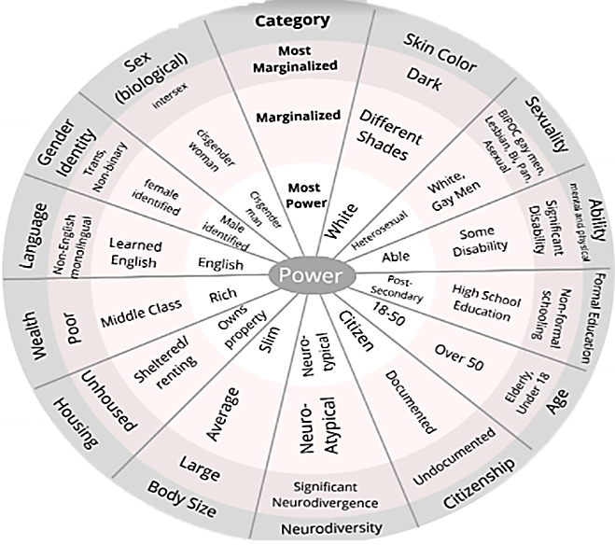

This is the best reference I could find. Let me know if you prefer to cite a different resource!
Wheel of Privilege and Power (wisc.edu)

